27 well-attributed, sole-authored Shakespearean Plays (on page 13 plus 14 new plays)

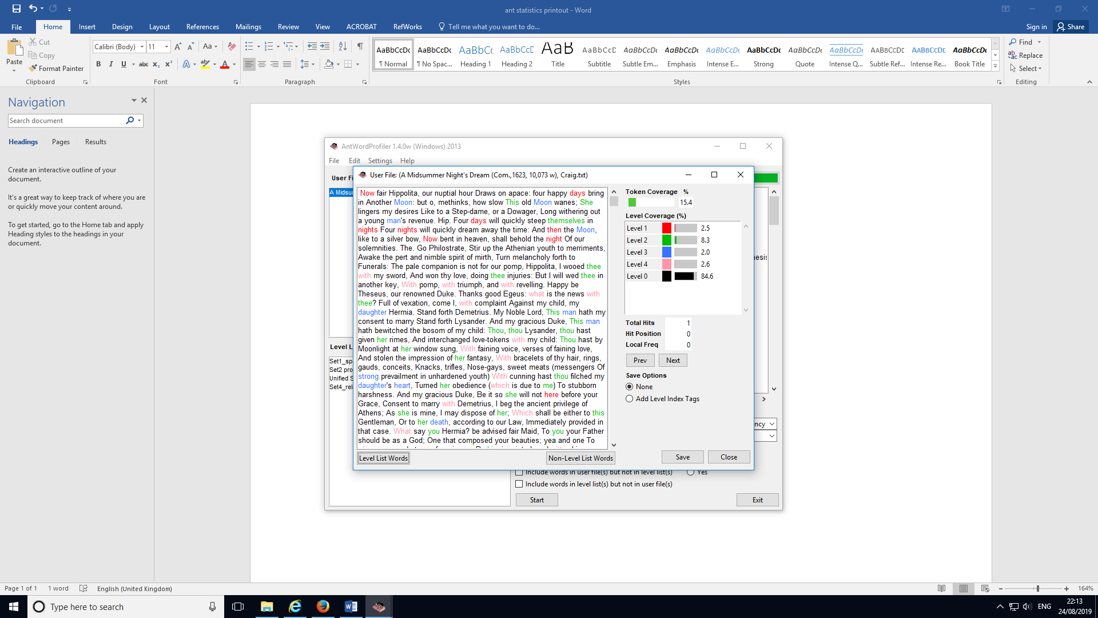

A Midsummer Night's Dream (Com.,1623, 10,073 w), Craig.txt

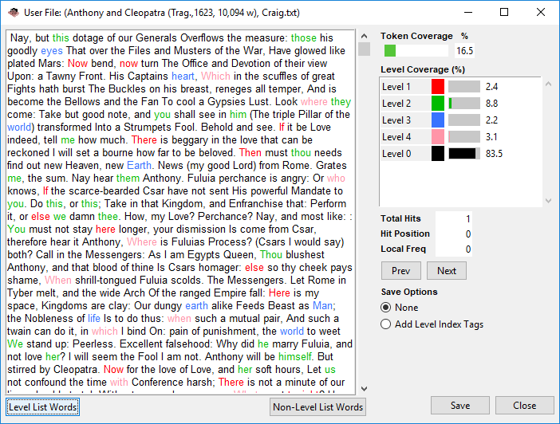

Anthony and Cleopatra (Trag.,1623, 10,094 w), Craig.txt

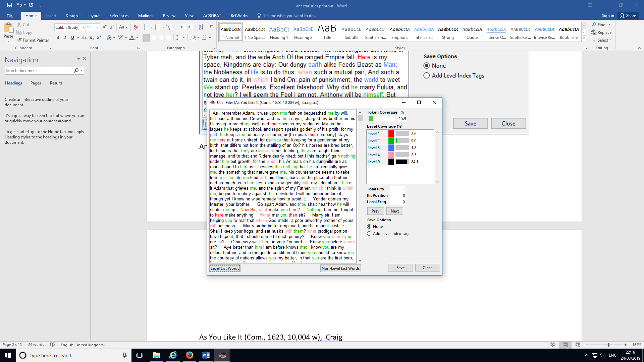

As You Like It (Com., 1623, 10,004 w), Craig

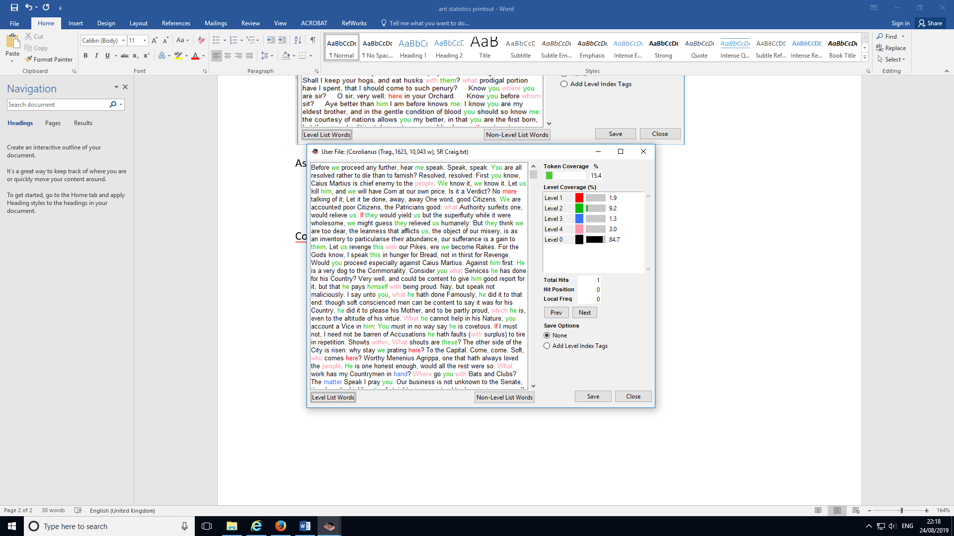

Corolianus (Trag.,1623, 10,043 w), SR Craig

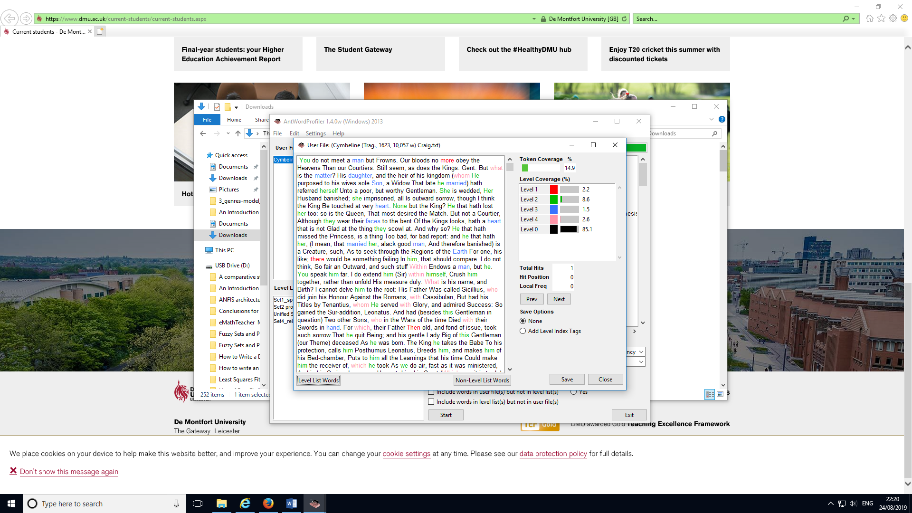

Cymbeline (Trag., 1623, 10,057 w) Craig.txt

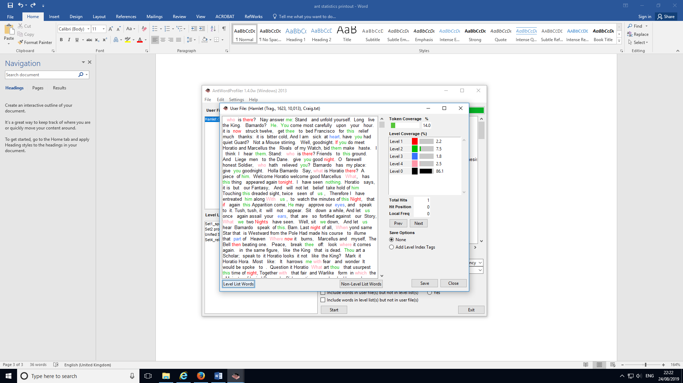

Hamlet (Trag., 1623, 10,013), Craig.txt

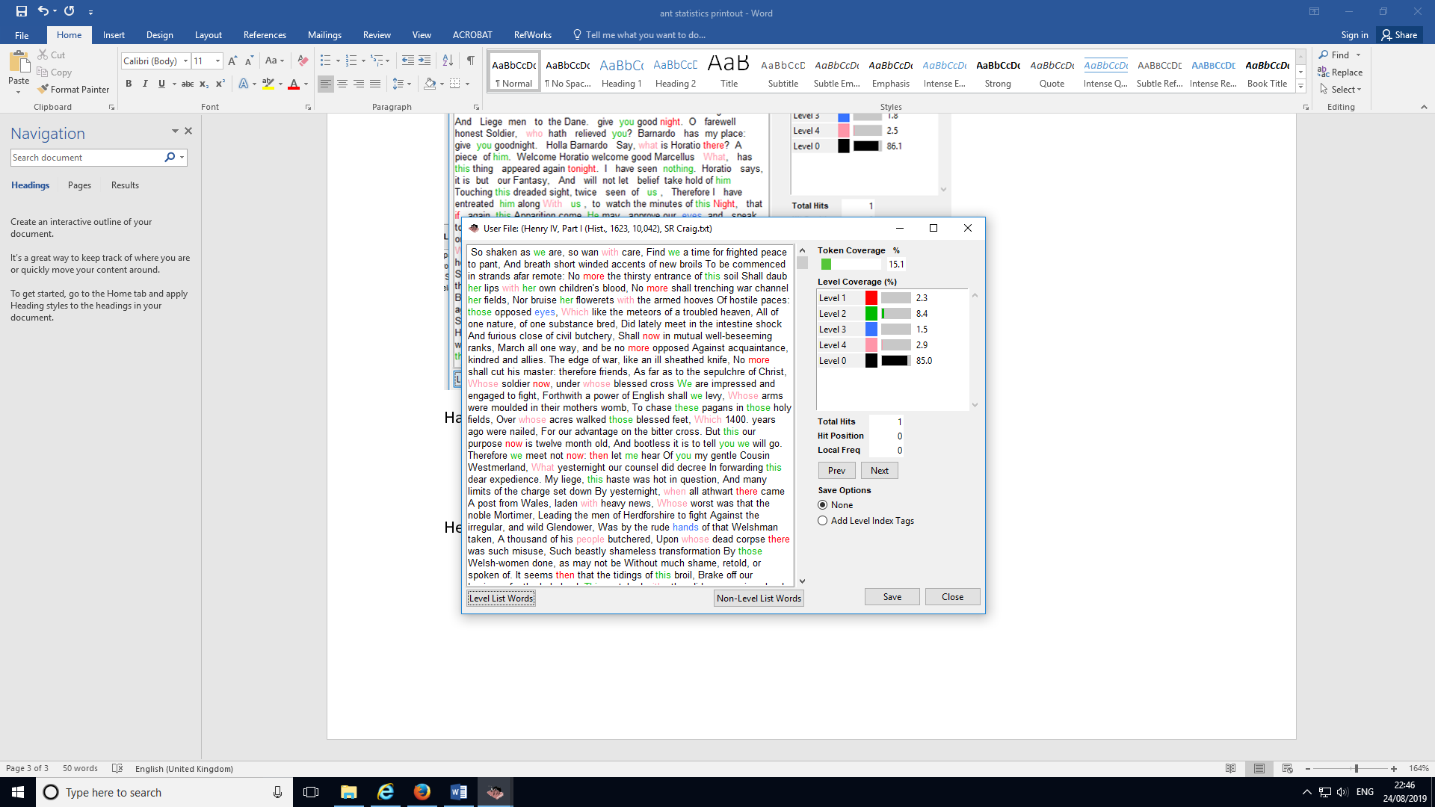

Henry IV, Part I (Hist., 1623, 10,042), SR Craig

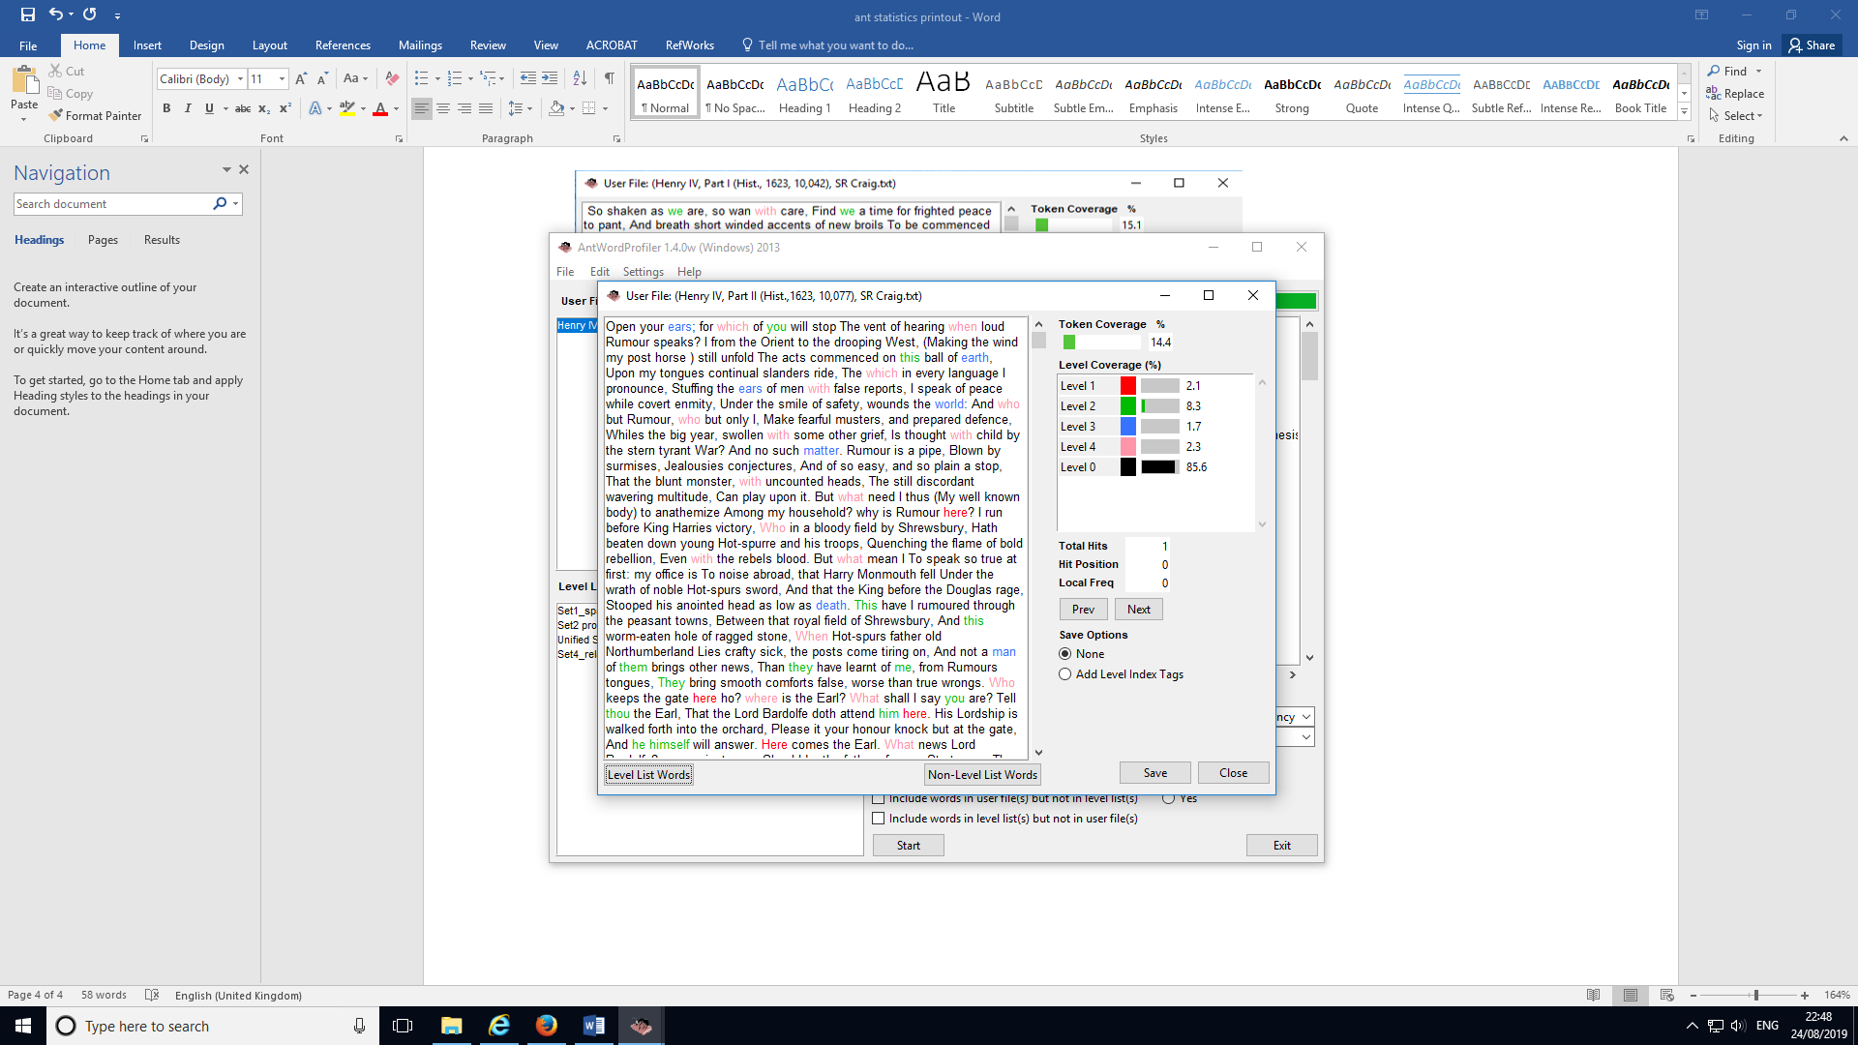

Henry IV, Part II (Hist.,1623, 10,077), SR Craig

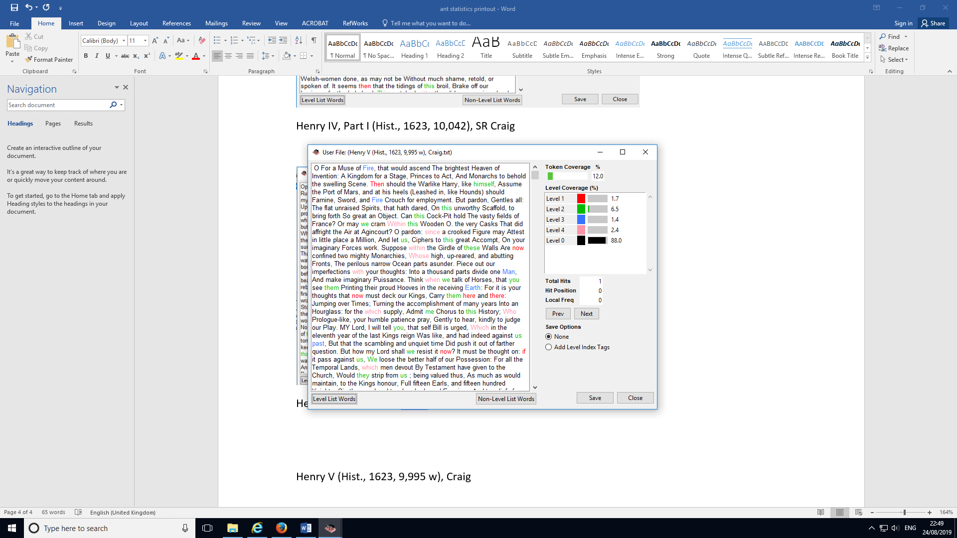

Henry V (Hist., 1623, 9,995 w), Craig

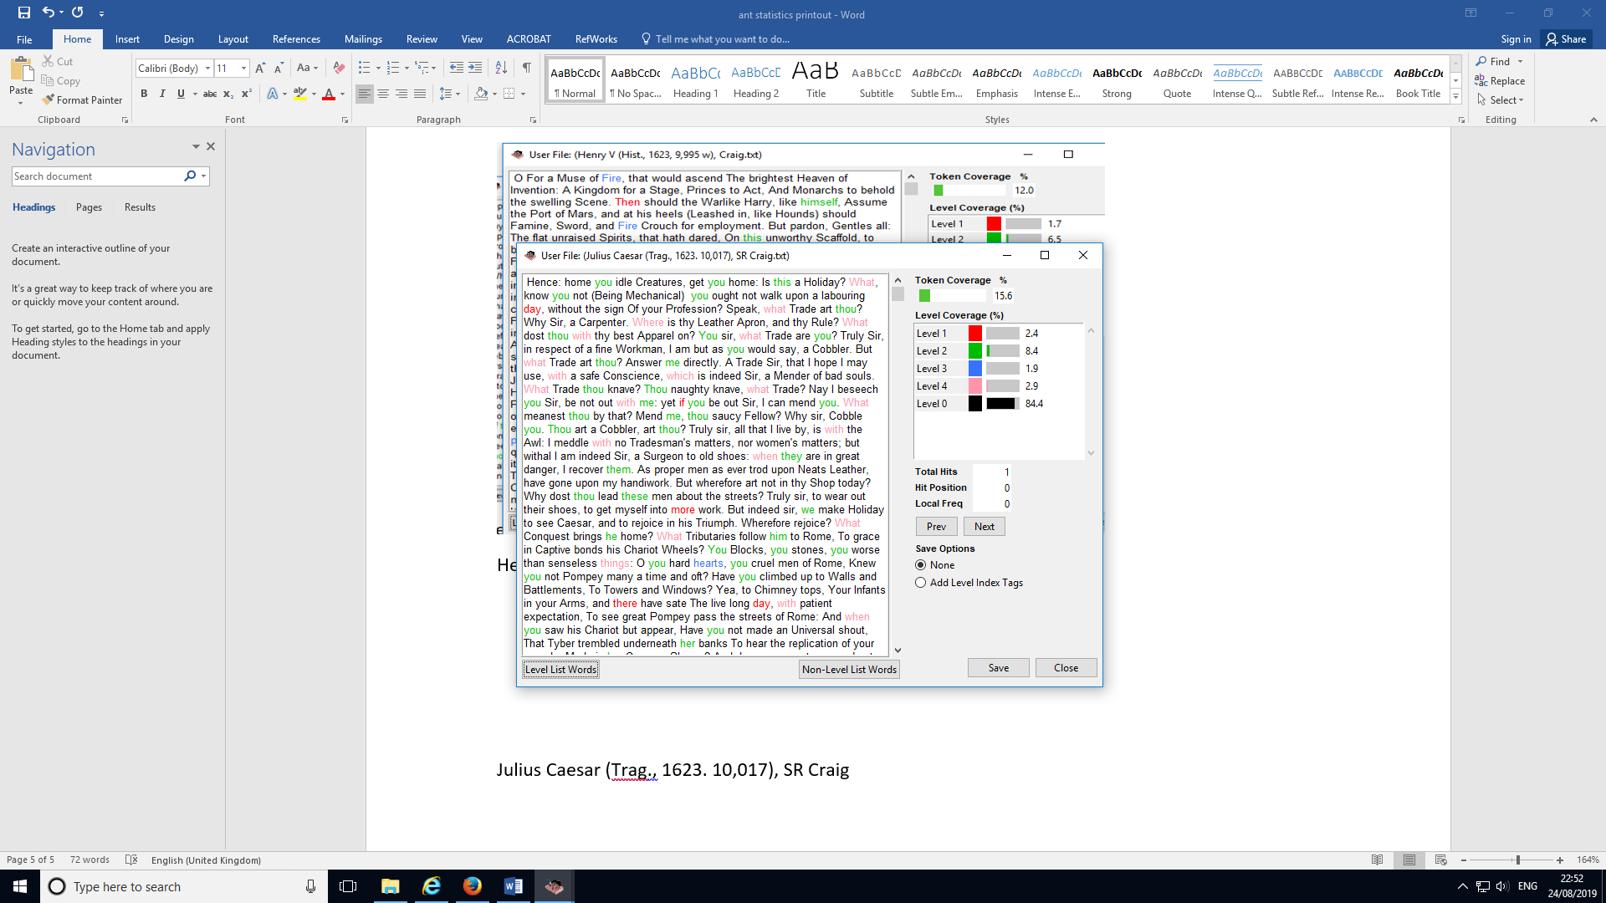

Julius Caesar (Trag., 1623. 10,017), SR Craig

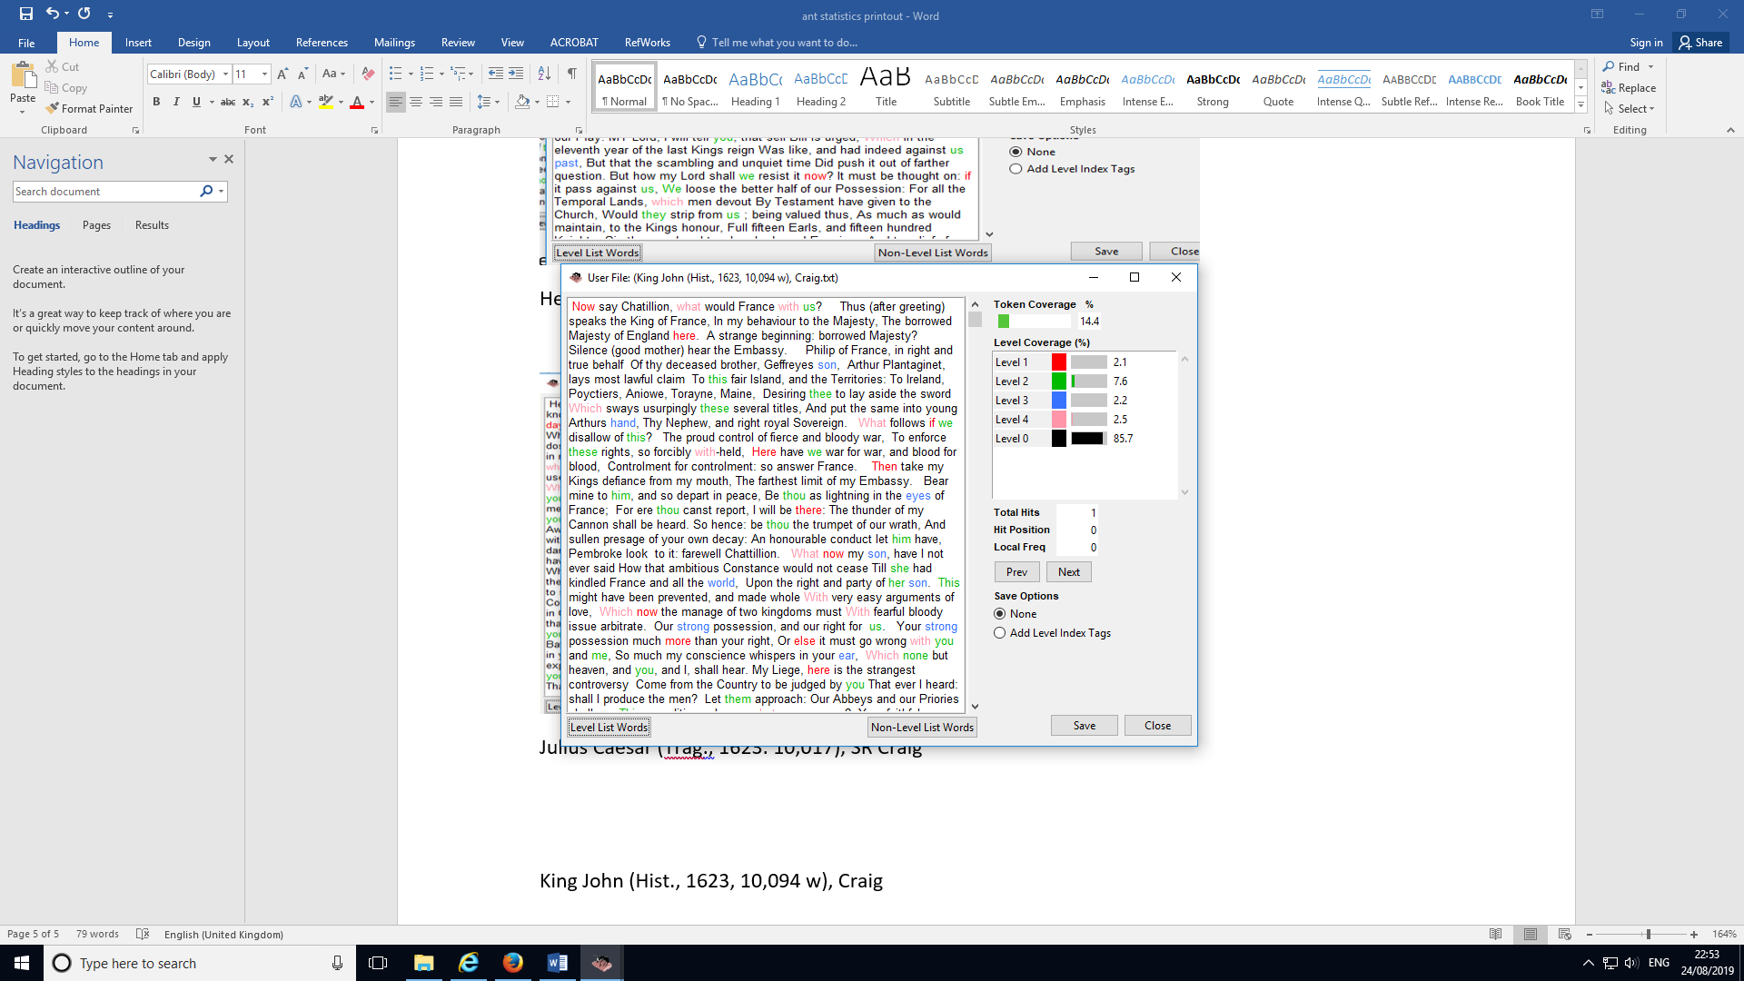

King John (Hist., 1623, 10,094 w), Craig

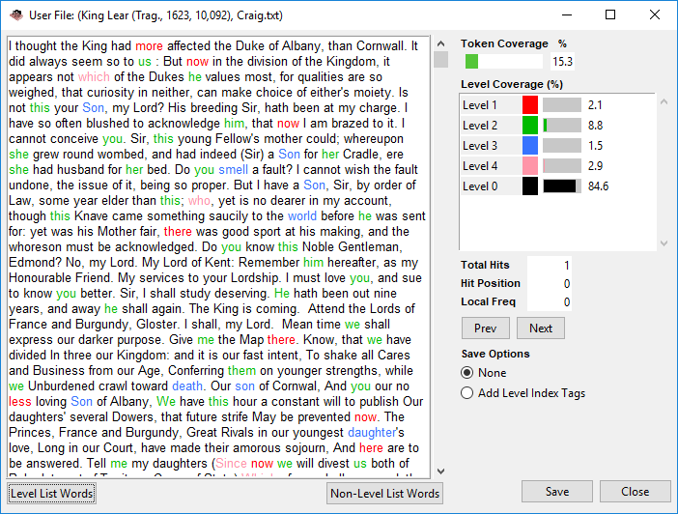

King Lear (Trag., 1623, 10,092), Craig.txt

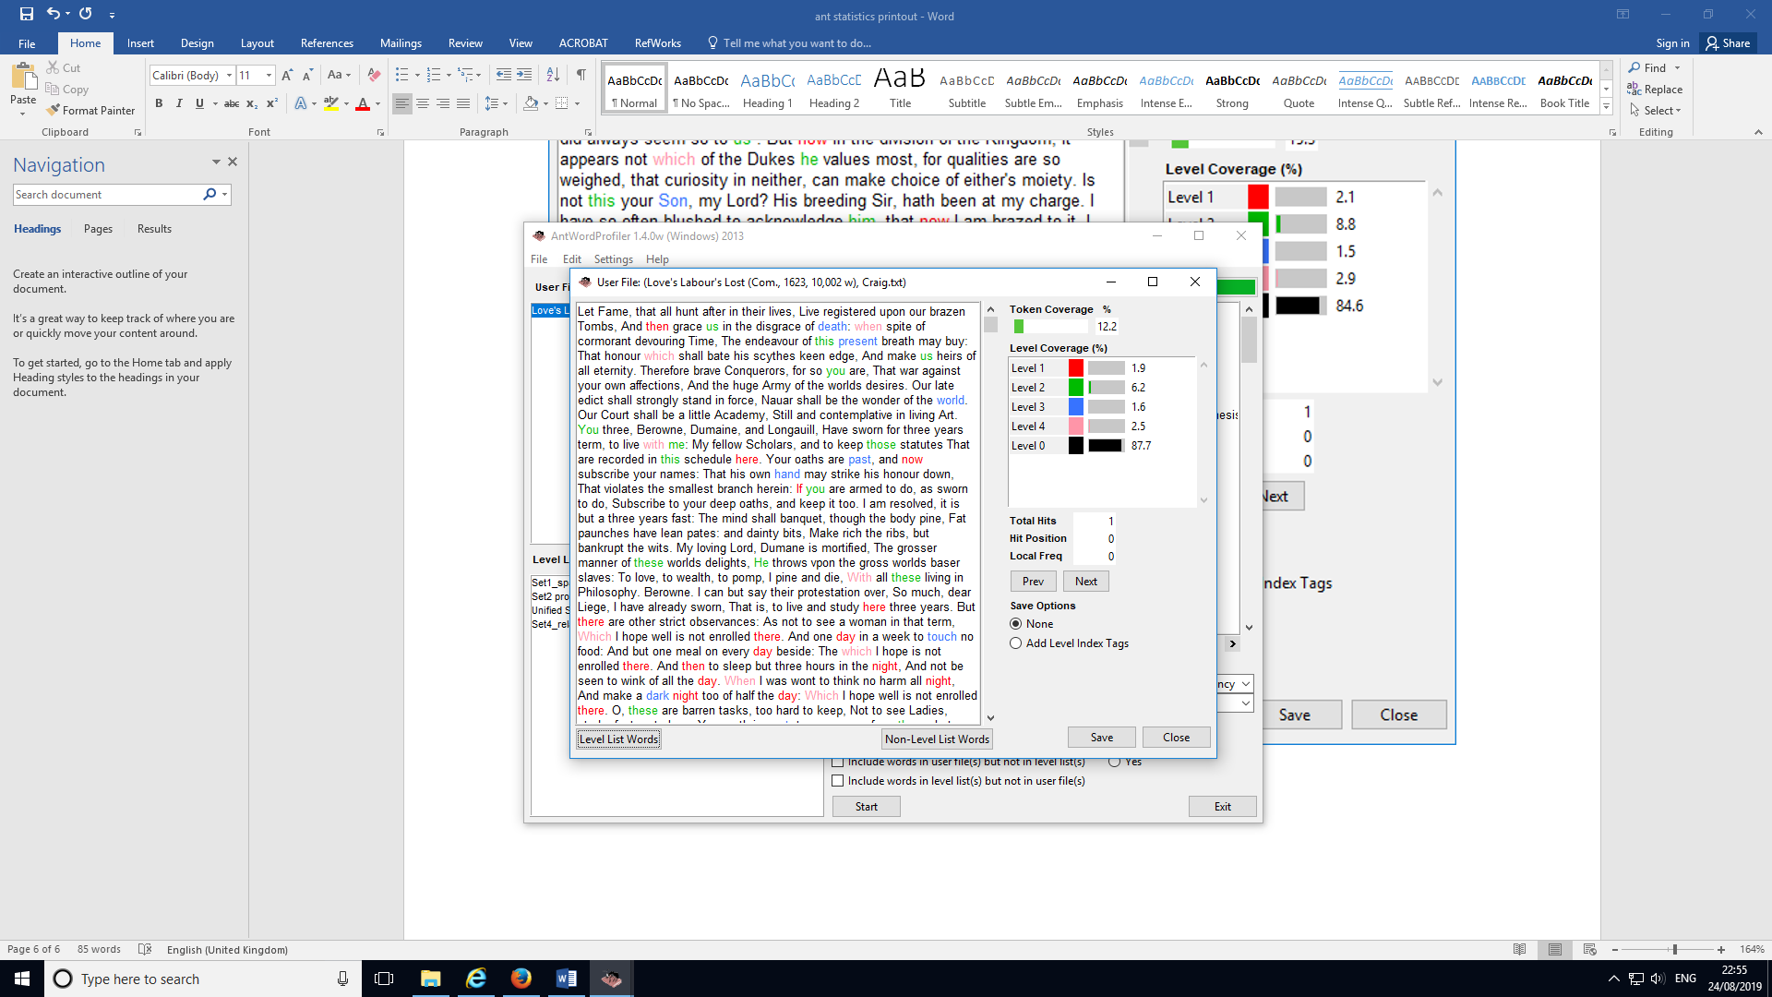

Love's Labour's Lost (Com., 1623, 10,002 w), Craig.txt

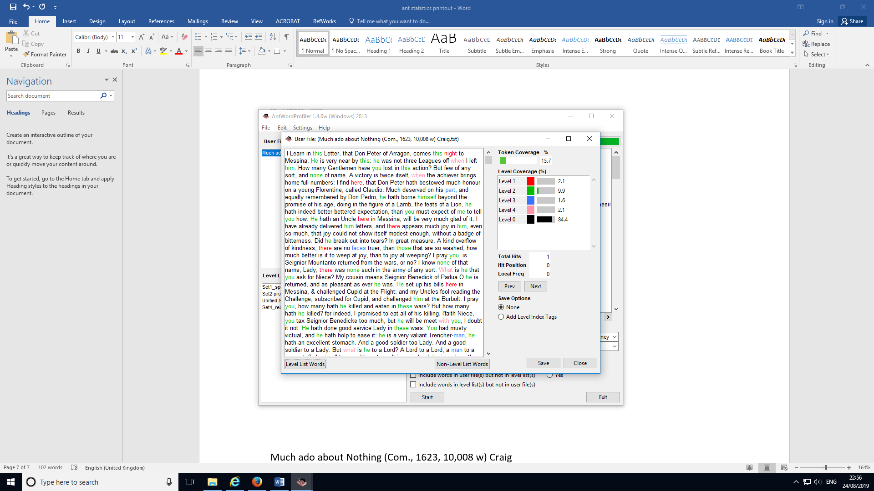

Much ado about Nothing (Com., 1623, 10,008 w) Craig

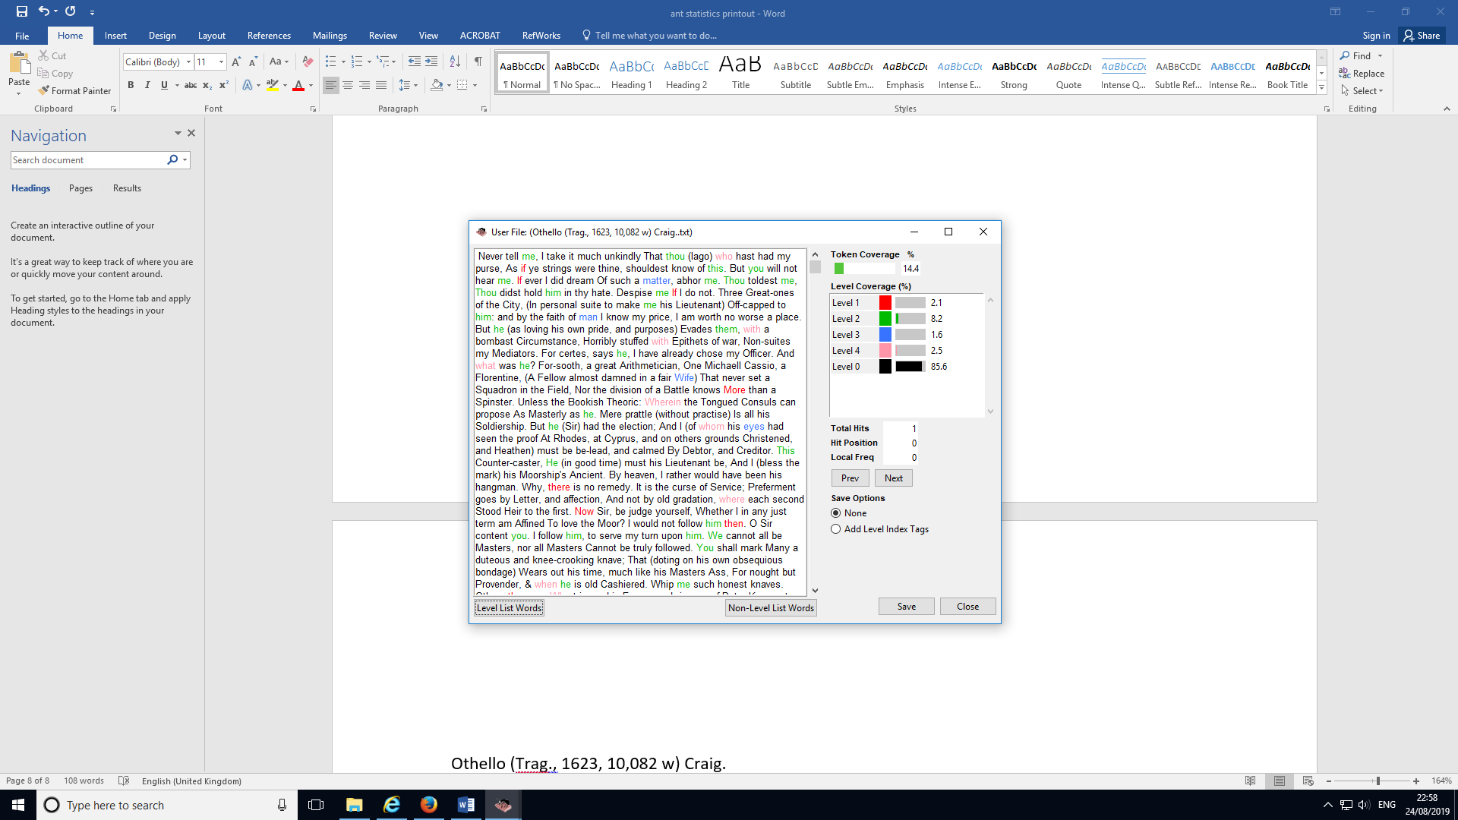

Othello (Trag., 1623, 10,082 w) Craig.

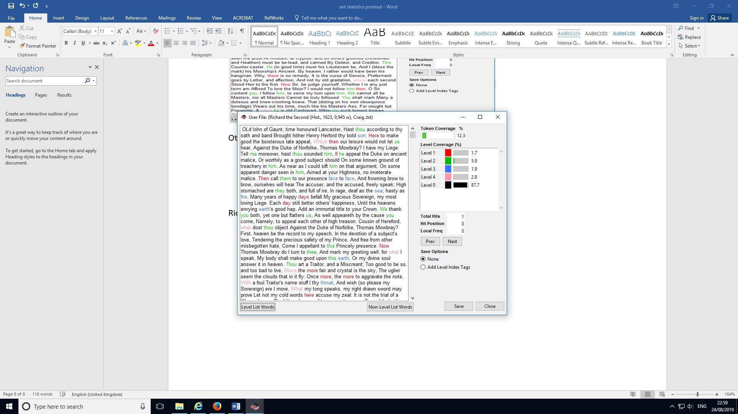

Richard the Second (Hist., 1623, 9,945 w), Craig.

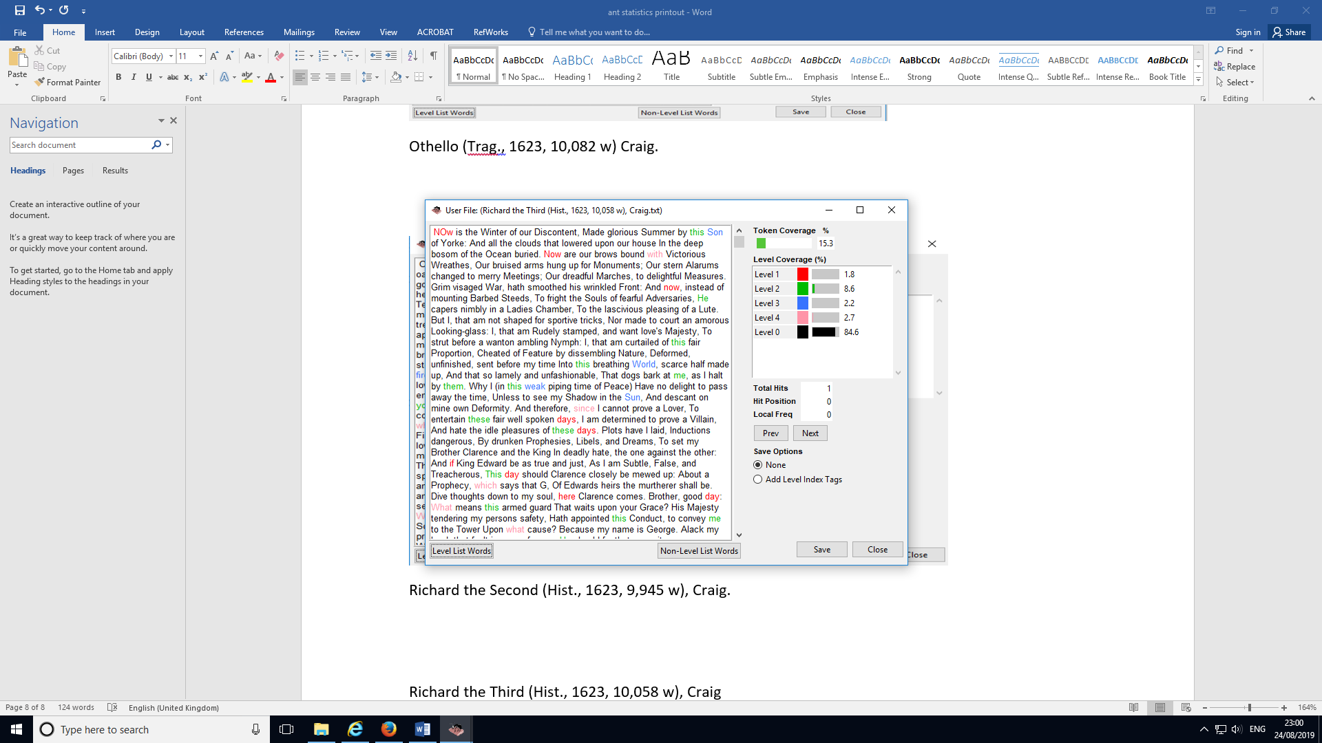

Richard the Third (Hist., 1623, 10,058 w), Craig

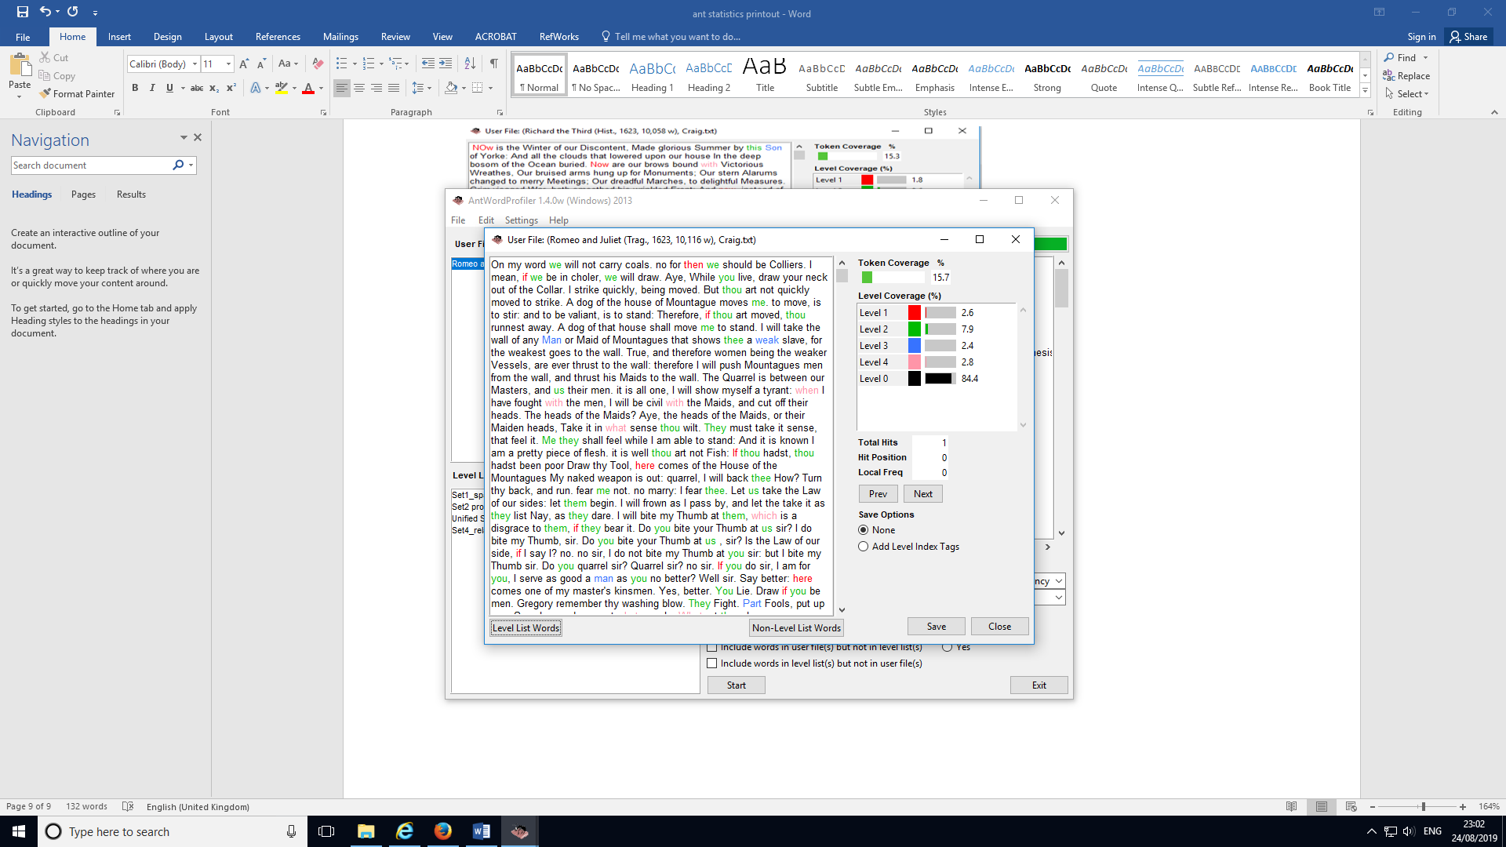

Romeo and Juliet (Trag., 1623, 10,116 w), Craig

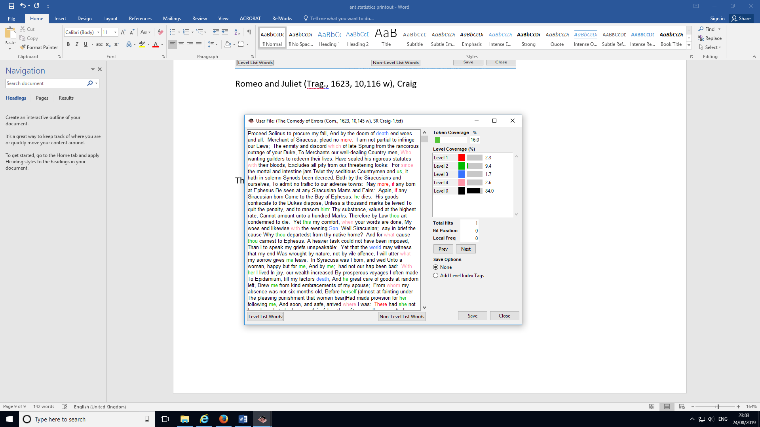

The Comedy of Errors (Com., 1623, 10,145 w), SR Craig

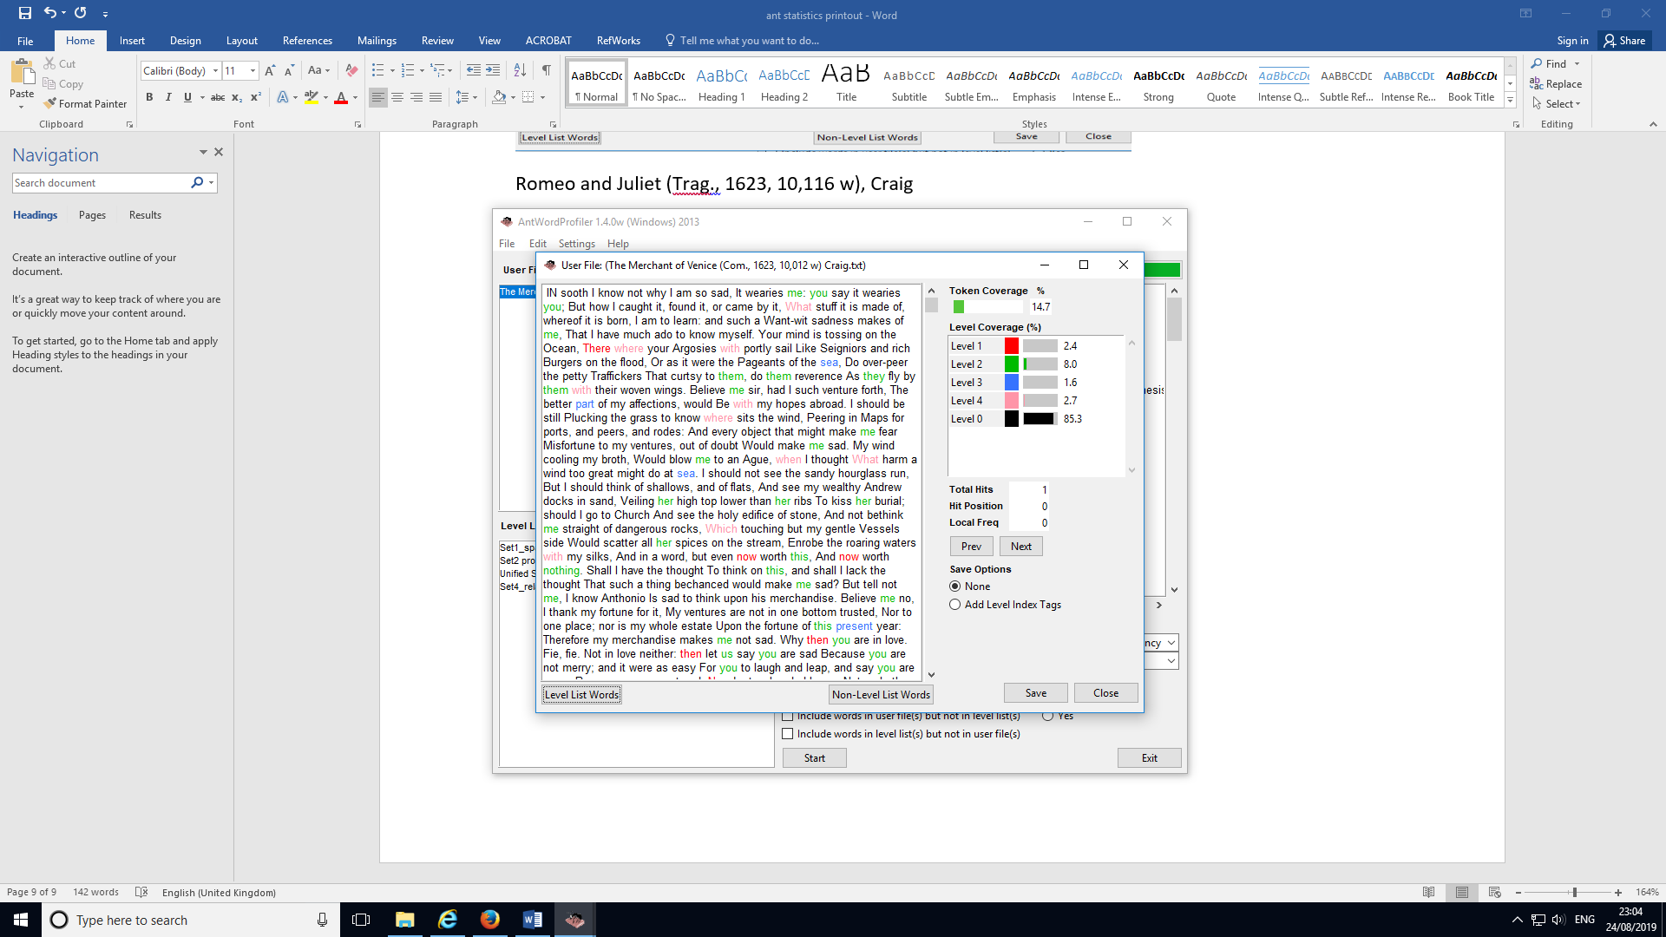

The Merchant of Venice (Com., 1623, 10,012 w) Craig.txt

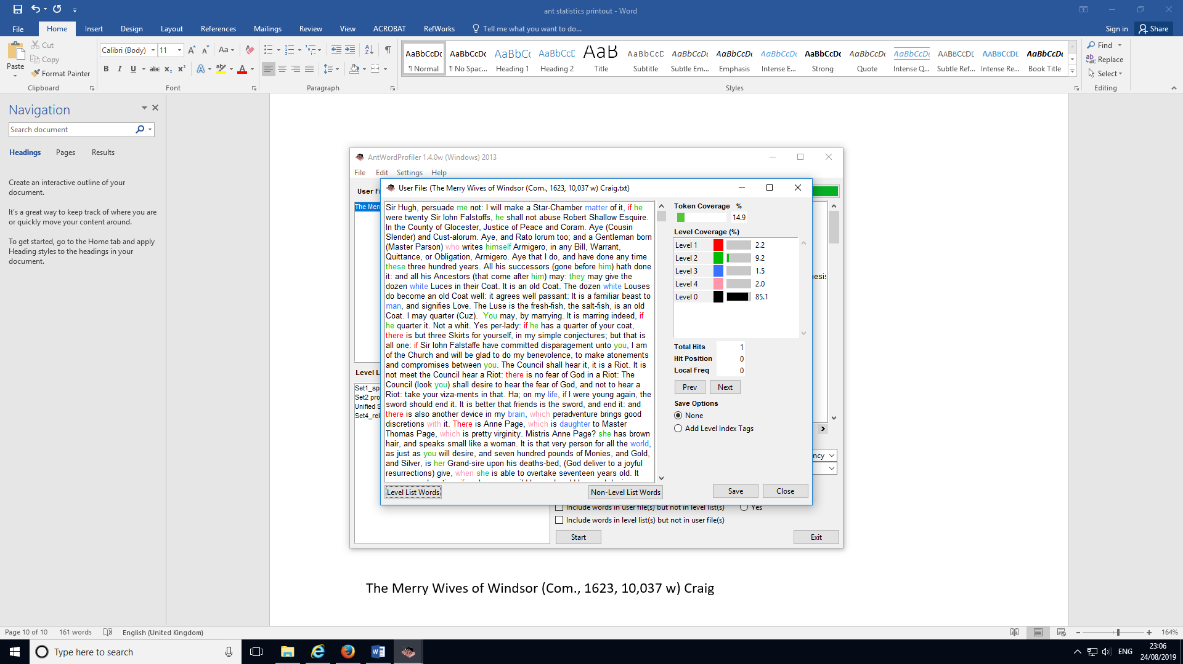

The Merry Wives of Windsor (Com., 1623, 10,037 w) Craig

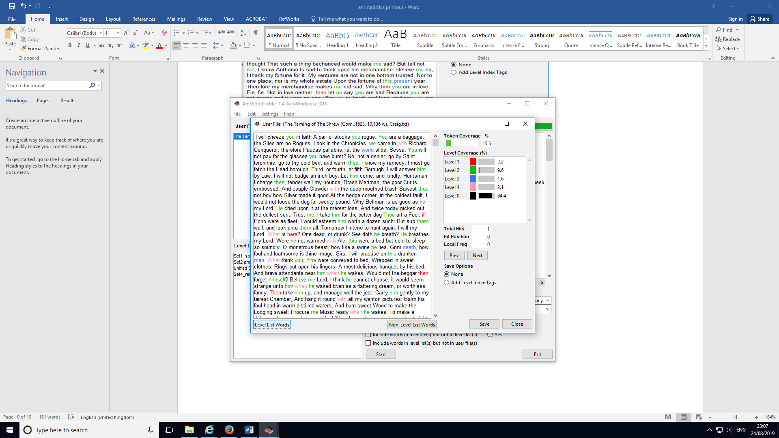

The Taming of The Shrew (Com.,1623, 10,136 w), Craig.txt

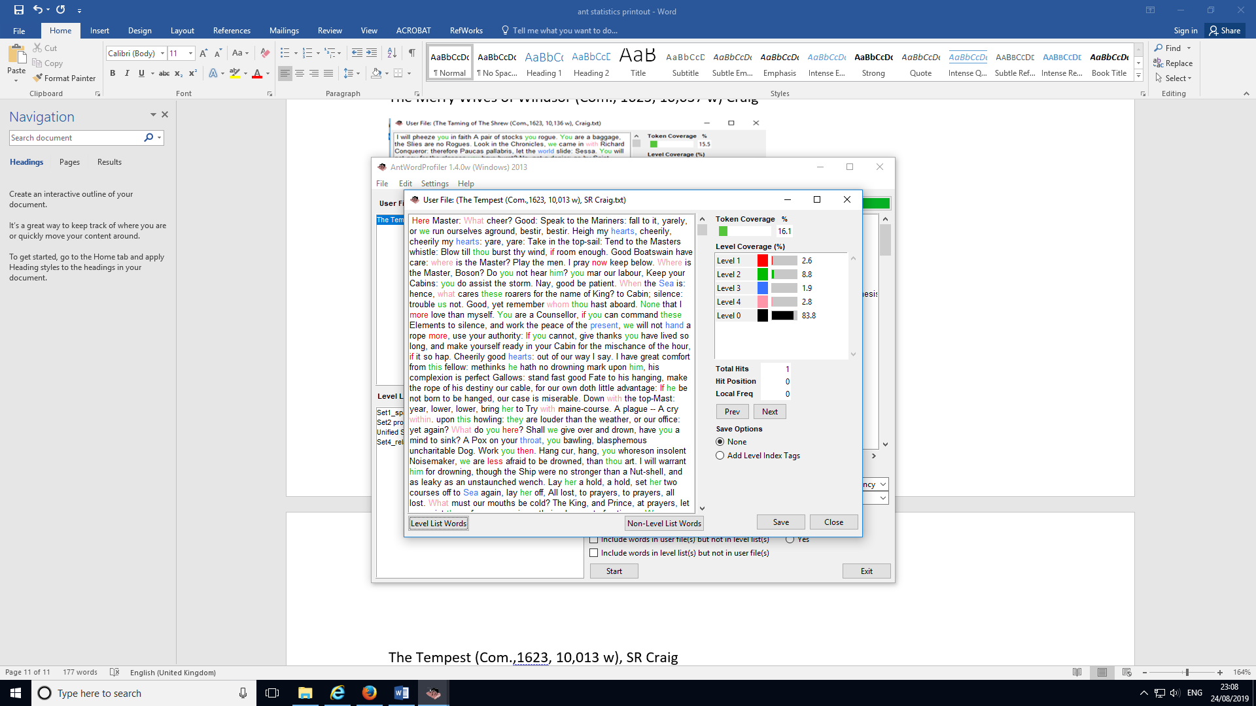

The Tempest (Com.,1623, 10,013 w), SR Craig

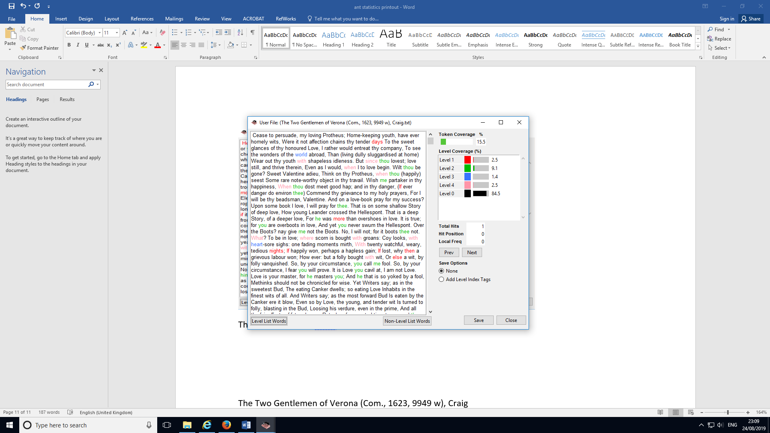

The Two Gentlemen of Verona (Com., 1623, 9949 w), Craig

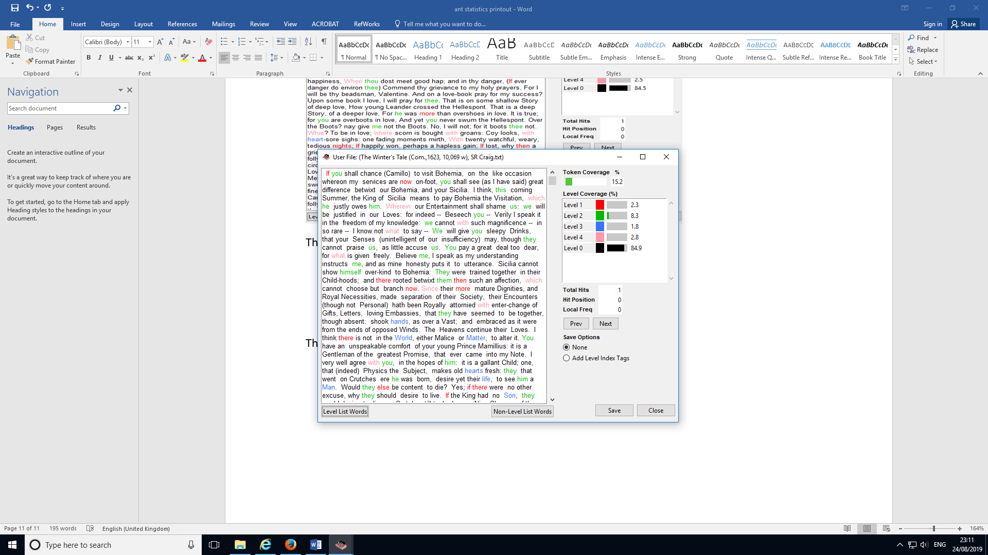

The Winter's Tale (Com.,1623, 10,069 w), SR Craig.txt

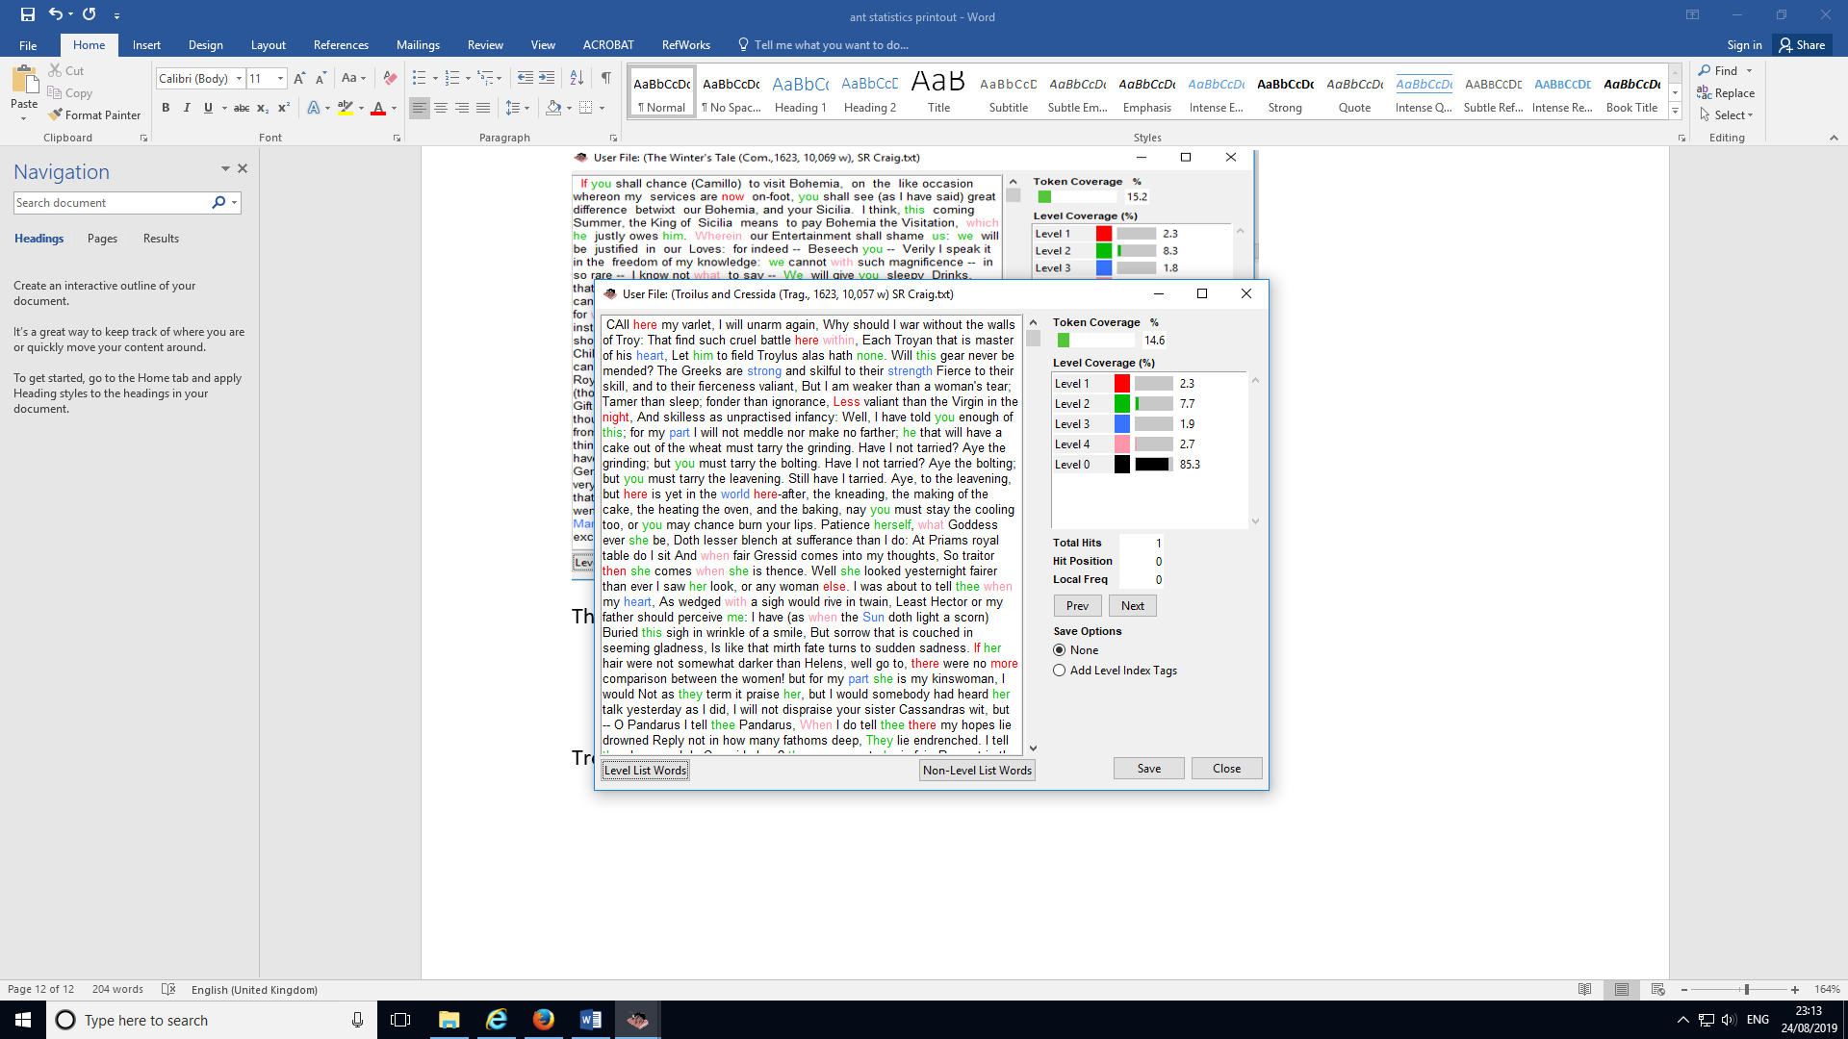

Troilus and Cressida (Trag., 1623, 10,057 w) SR Craig

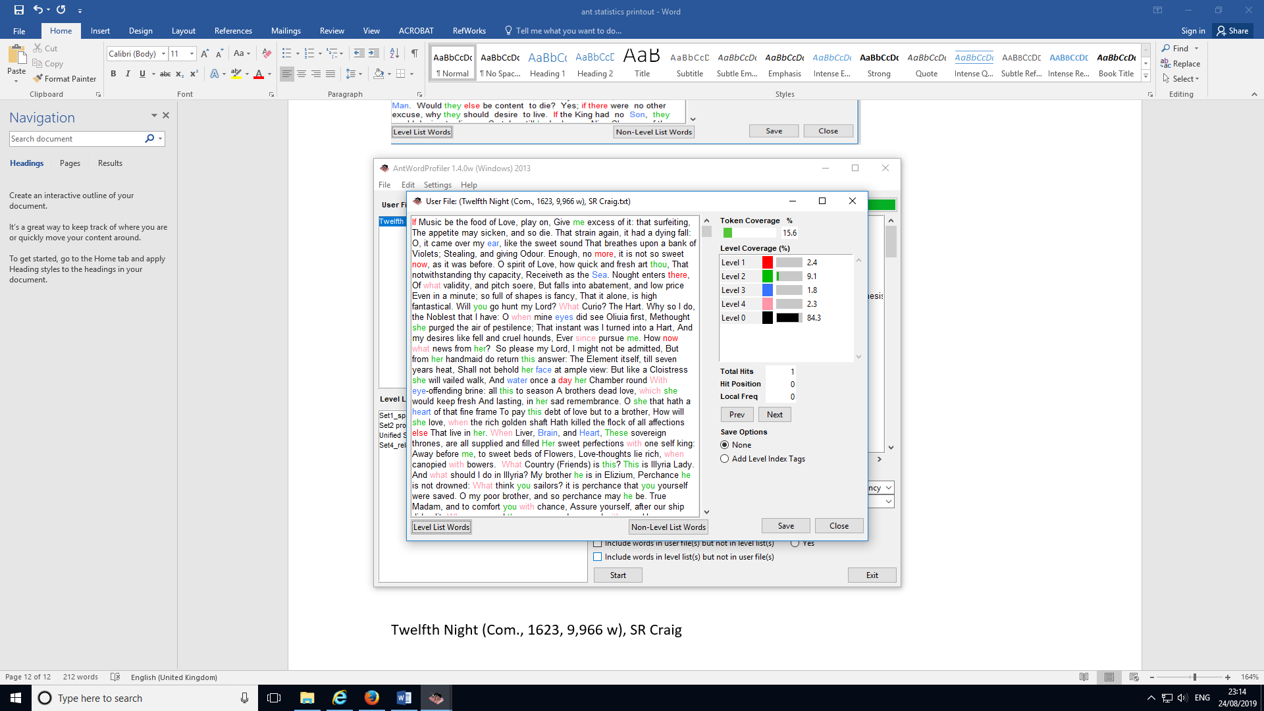

Twelfth Night (Com., 1623, 9,966 w), SR Craig

14 Plays for Validation Stage 2 and Testing Stage

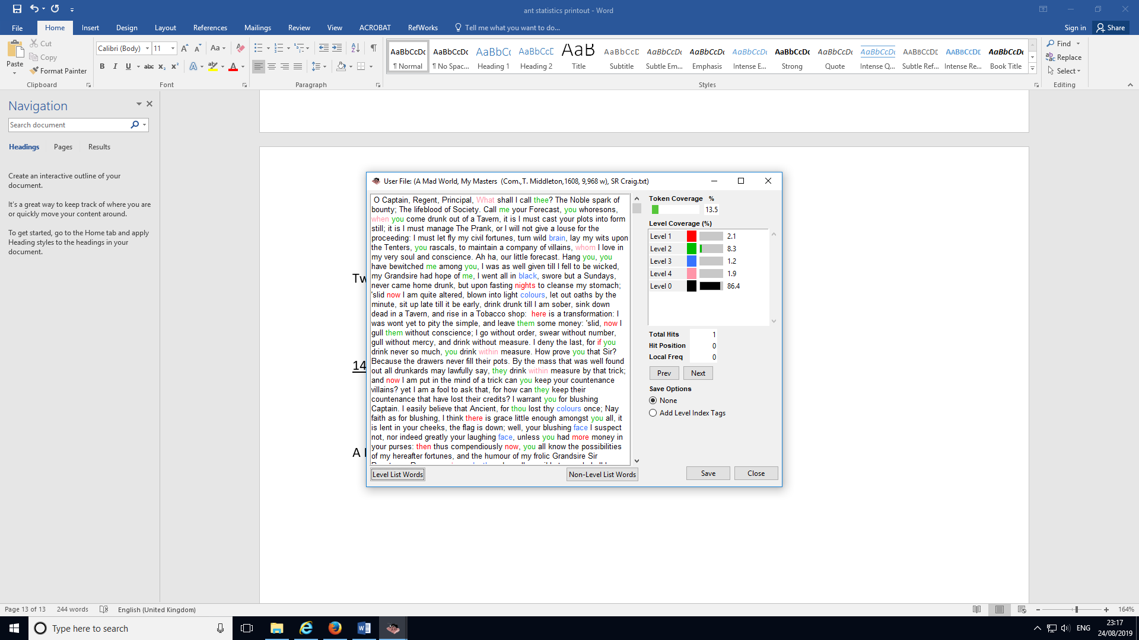

A Mad World, My Masters (Com.,T. Middleton,1608, 9,968 w), SR Craig

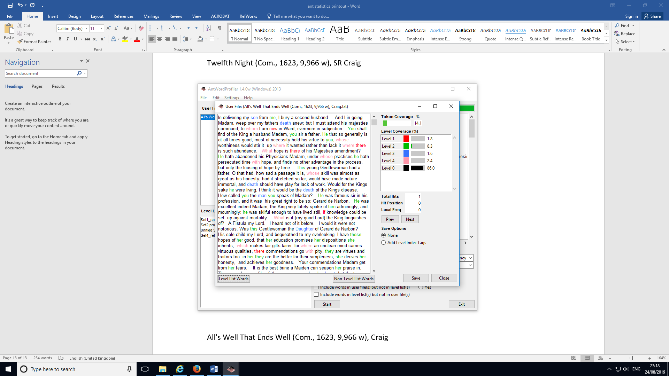

All's Well That Ends Well (Com., 1623, 9,966 w), Craig

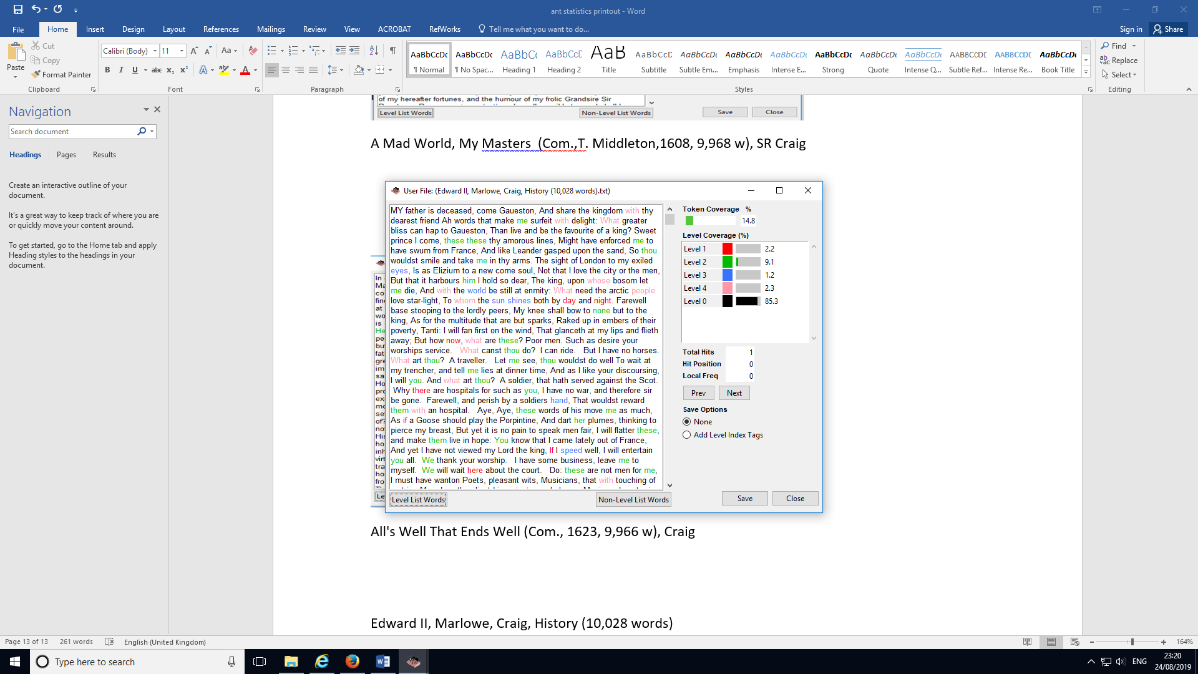

Edward II, Marlowe, Craig, History (10,028 words)

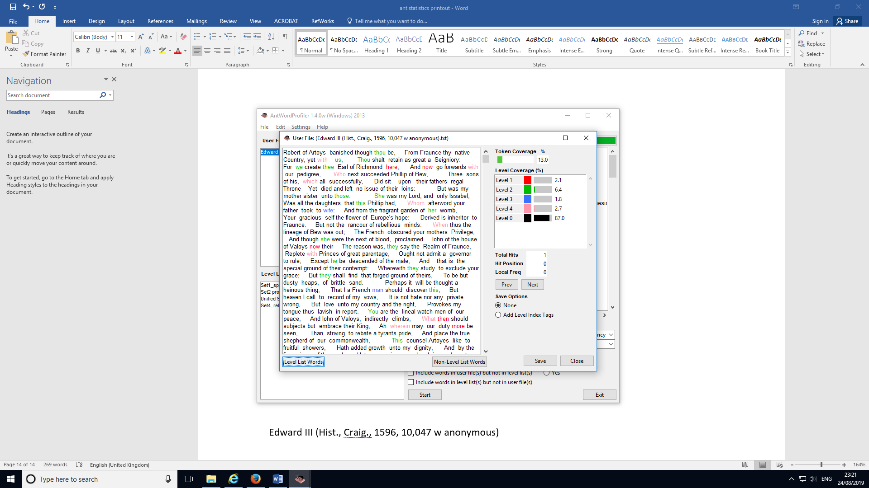

Edward III (Hist., Craig., 1596, 10,047 w anonymous)

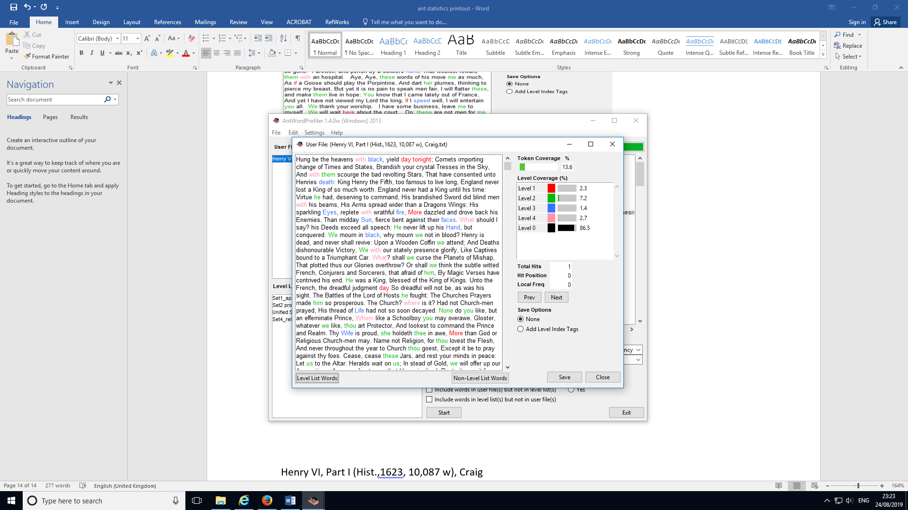

Henry VI, Part I (Hist.,1623, 10,087 w), Craig

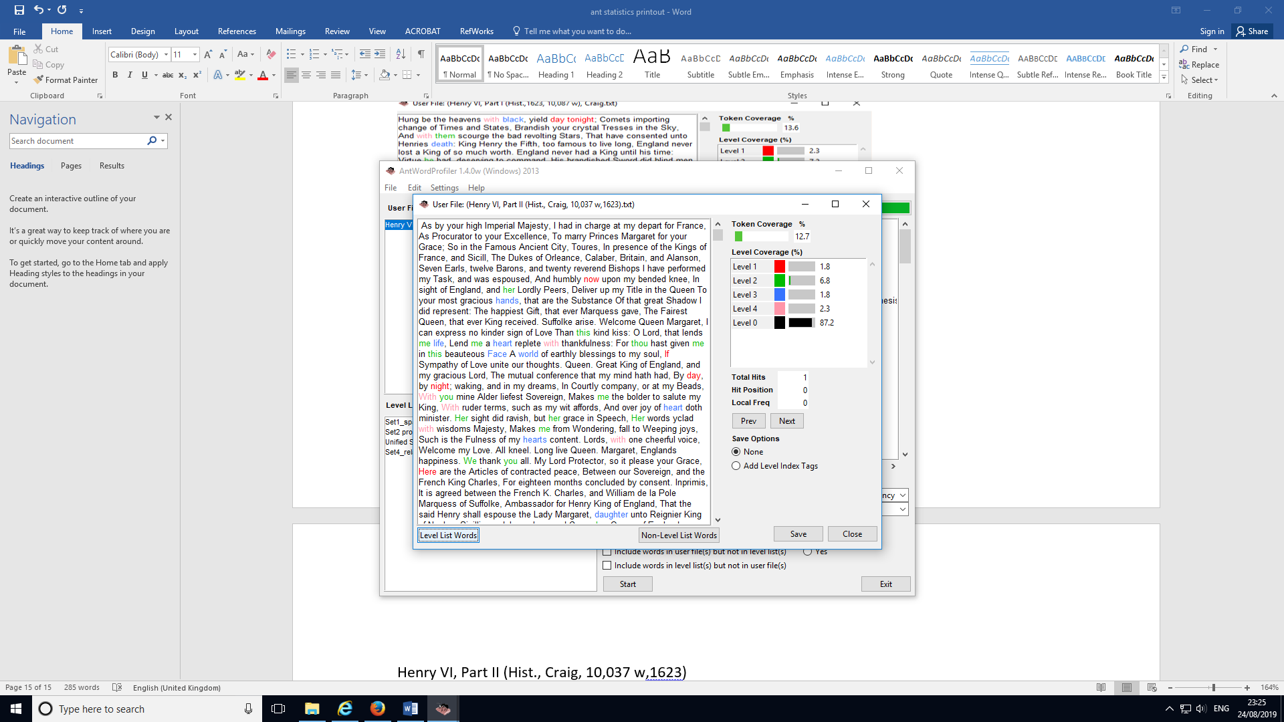

Henry VI, Part II (Hist., Craig, 10,037 w, 1623)

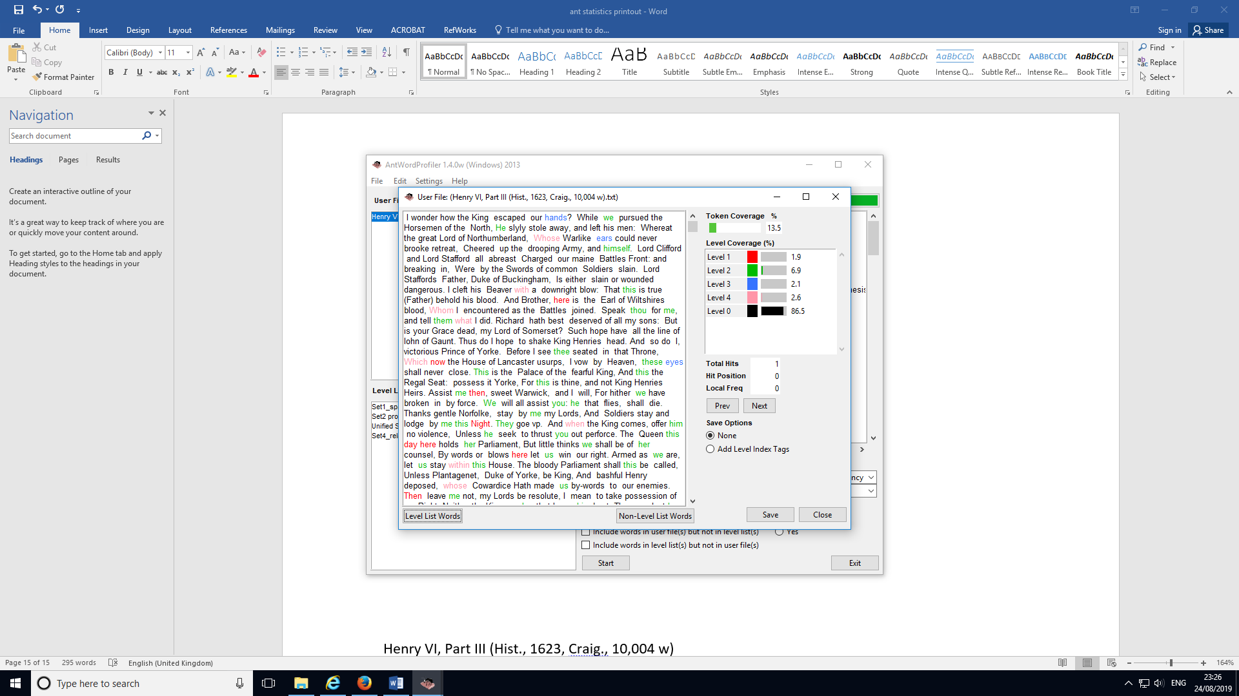

Henry VI, Part III (Hist., 1623, Craig., 10,004 w)

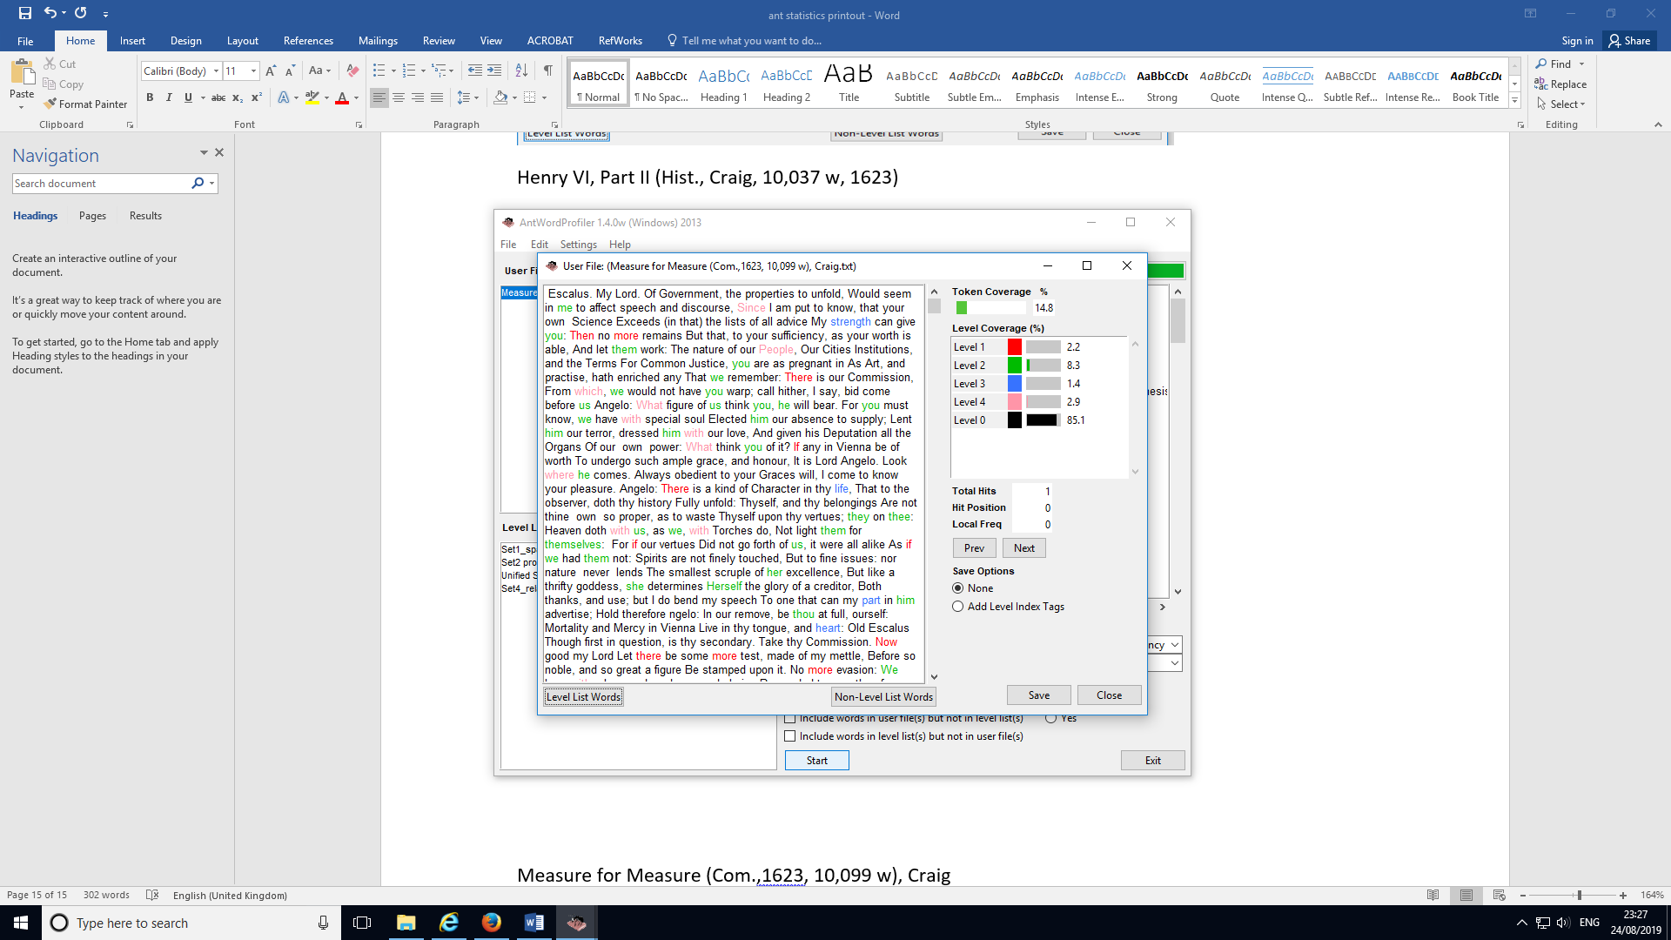

Measure for Measure (Com.,1623, 10,099 w), Craig

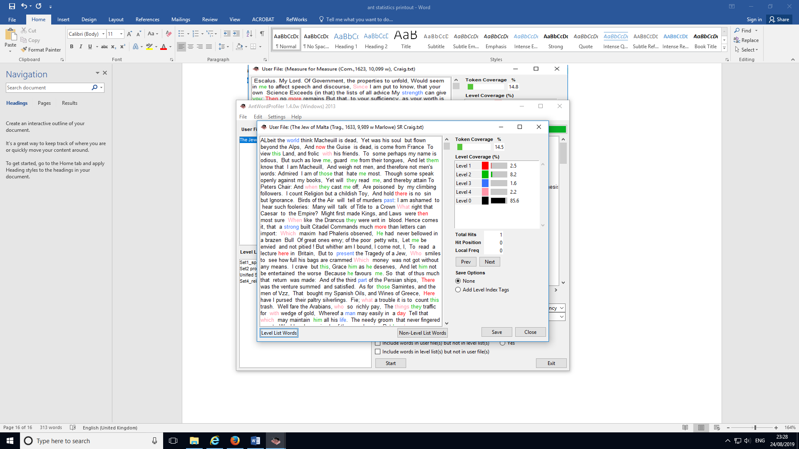

The Jew of Malta (Trag., 1633, 9,989 w Marlowe) SR Craig

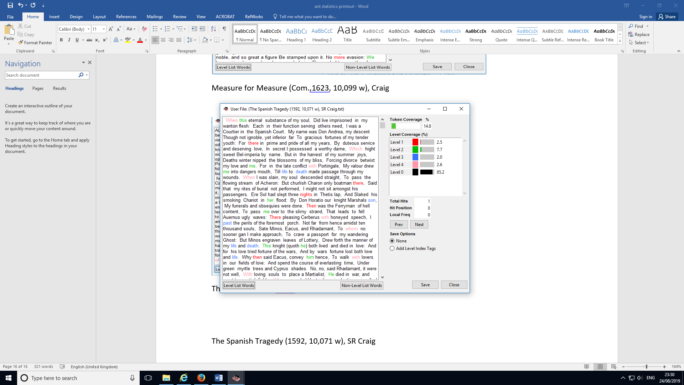

The Spanish Tragedy (1592, 10,071 w), SR Craig

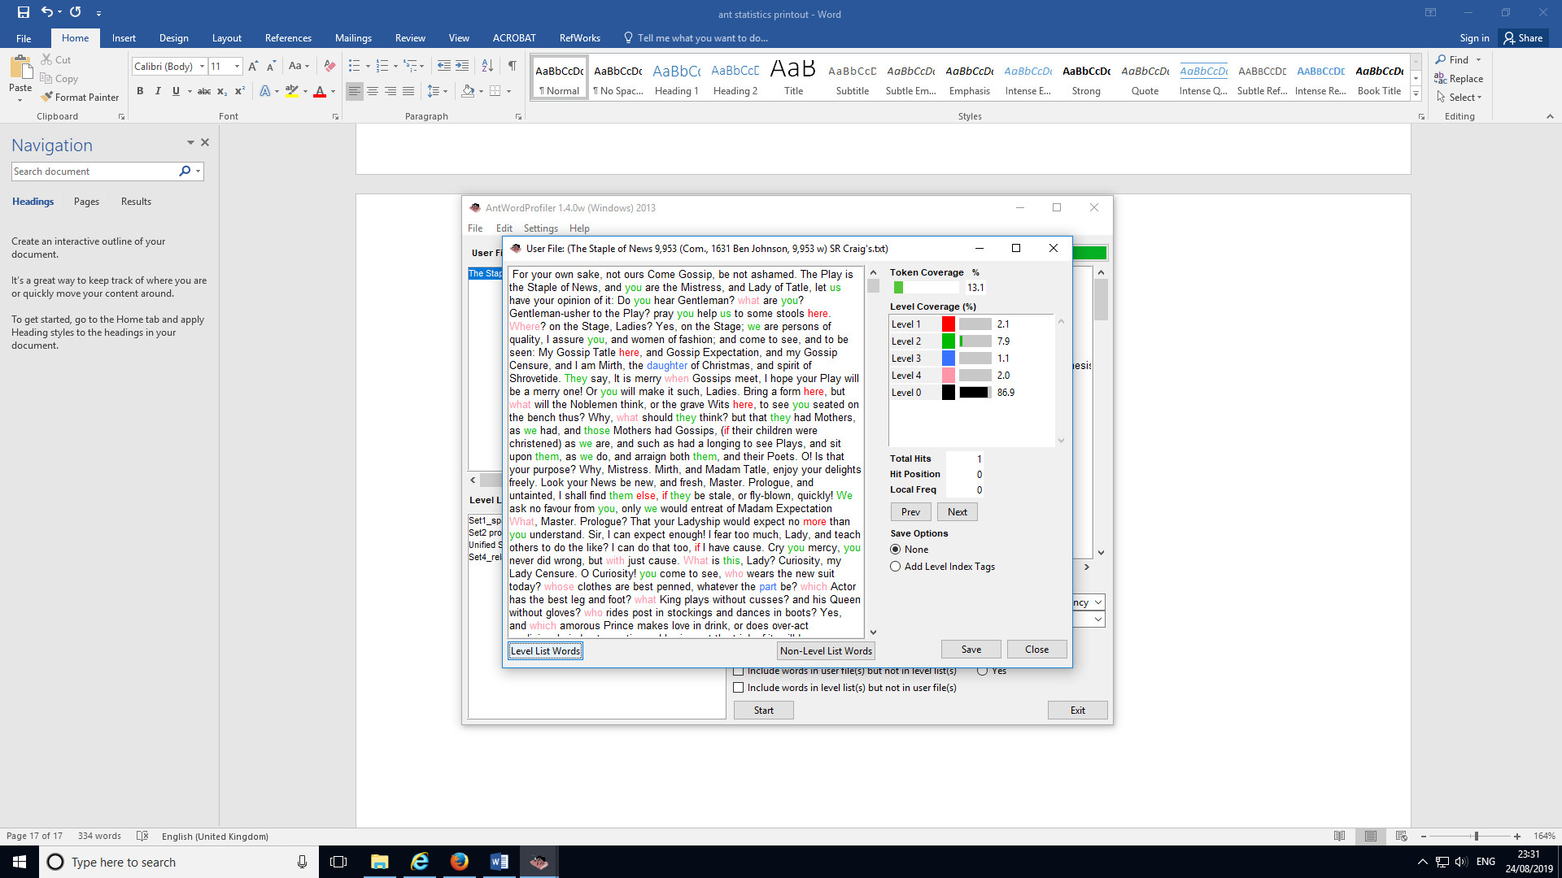

The Staple of News 9,953 (Com., 1631 Ben Johnson, 9,953 w) SR Craig's

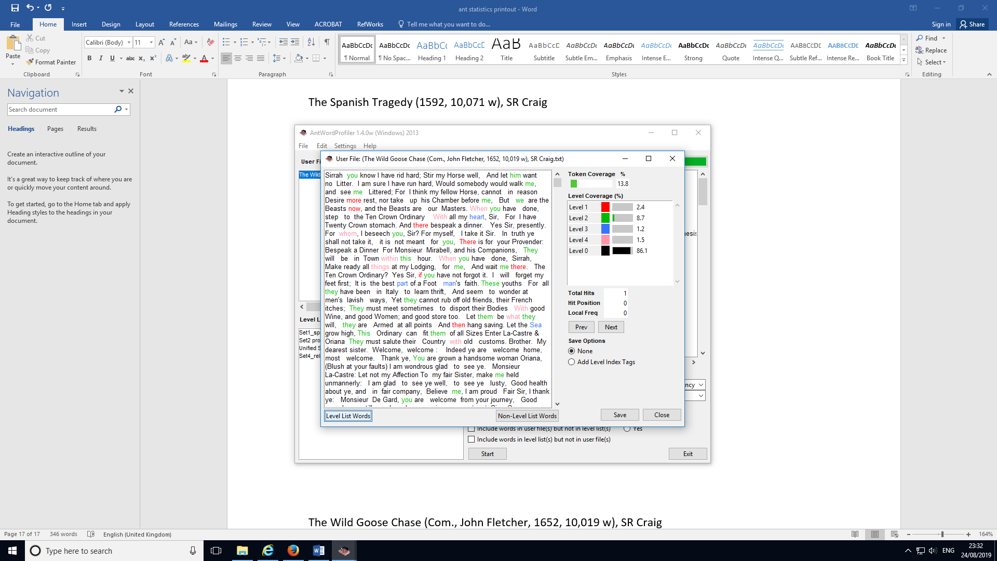

The Wild Goose Chase (Com., John Fletcher, 1652, 10,019 w), SR Craig

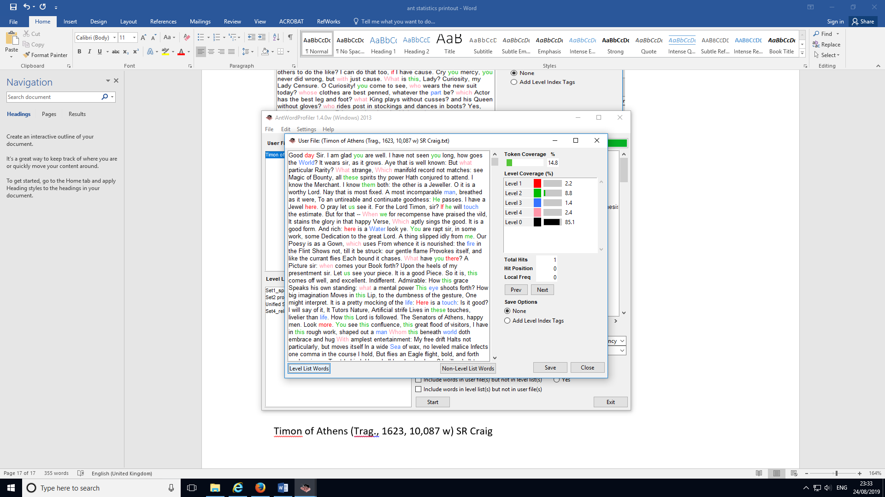

Timon of Athens (Trag., 1623, 10,087 w) SR Craig

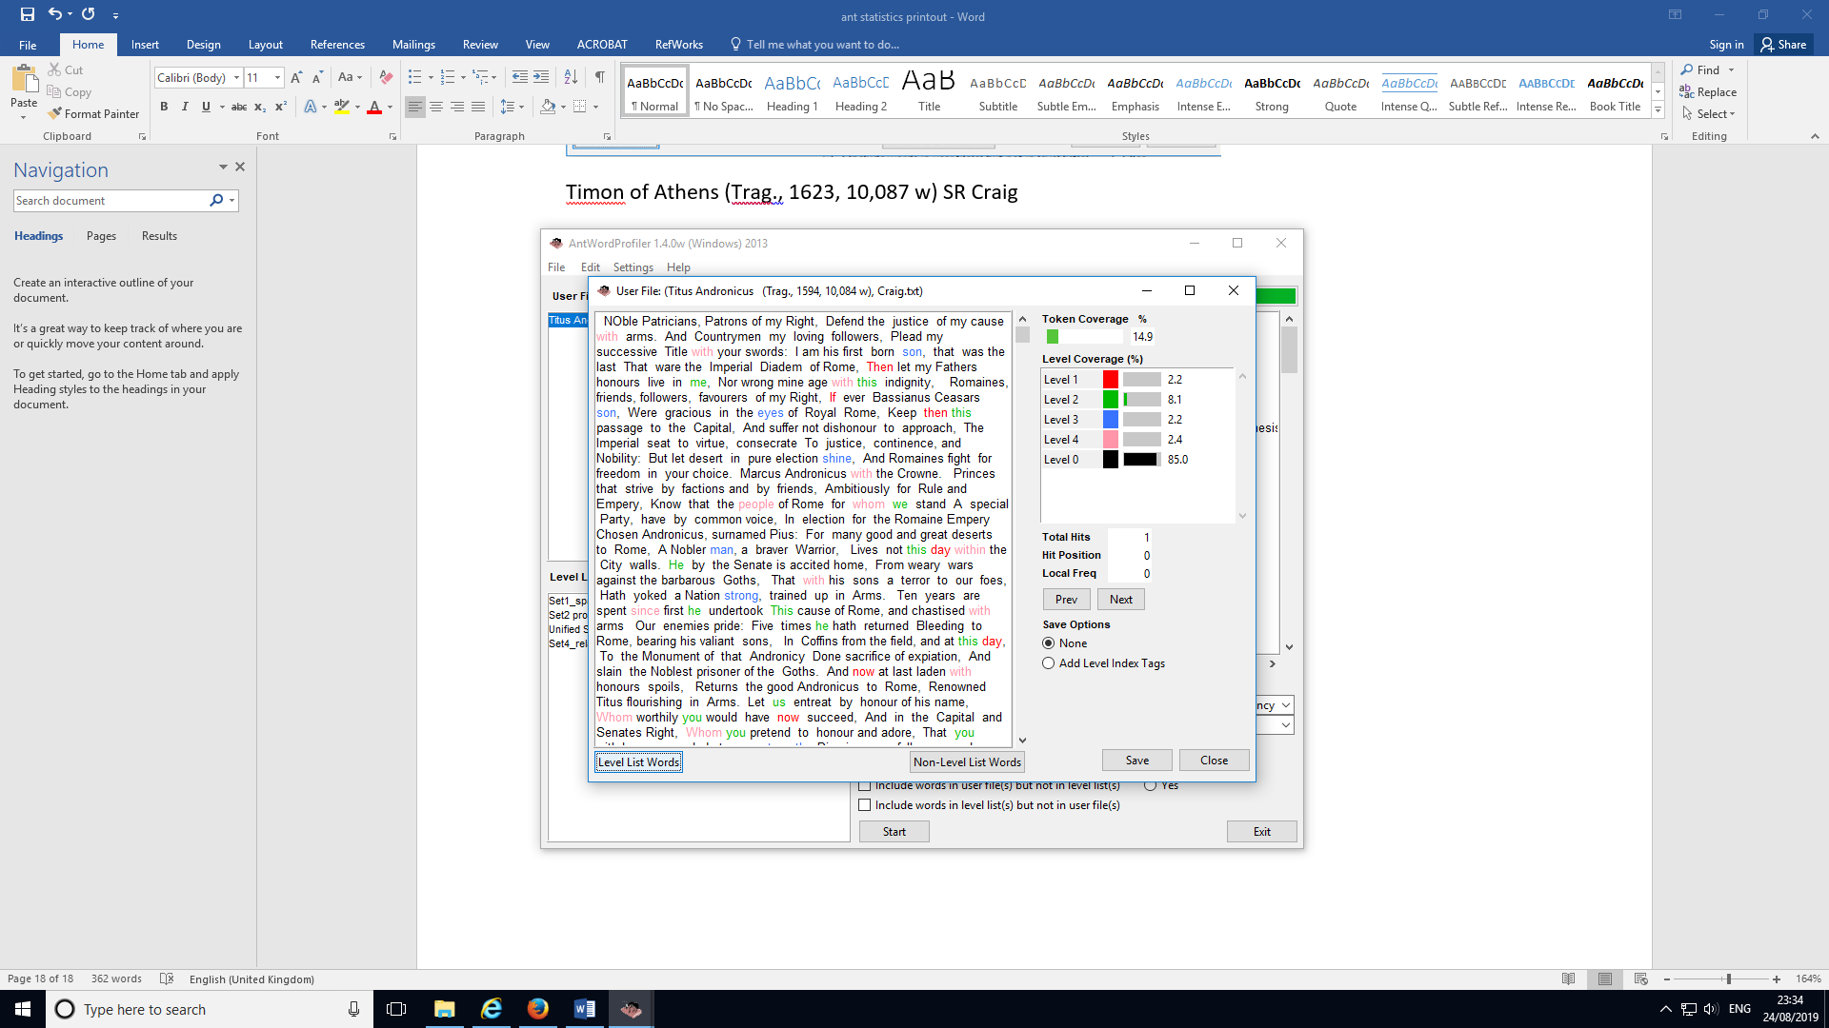

Titus Andronicus (Trag., 1594, 10,084 w), Craig

